
Name: …SOLUTIONS….
Mathematics Methods, Year 12, 2018
Test 1 – Further differentiation and applications

Total | /27 | %

25 minutes working time.
Calculator Assumed Section (notes allowed)
SCSA Formula sheet and calculators allowed

8. [9 marks: 3, 6]
A closed cylindrical can of radius r cm has a volume of 250𝜋 cm³.
a) Show that the total surface area, A cm², of this can is given by $A=\frac{500π}{r}+2πr^{2}$.
$V=πr^{2}h$
$250π=πr^{2}h⇒h=\frac{250}{r^{2}}$
$A=2πr^{2}+2πrh$
$=2πr^{2}+2πr\frac{250}{r^{2}}$
$=\frac{500π}{r}+2πr^{2}$

b) Use derivatives to determine the minimum possible total surface area of the can, justifying that it is a minimum, and state the radius and height required to achieve this minimum area
$\frac{dA}{dr}=-\frac{500π}{r^{2}}+4πr$
$-\frac{500π}{r^{2}}+4πr=0$
$r^{3}=125⇒r=5 cm$
${\left.\frac{d^{2}A}{d}=\frac{1000π}{r^{3}}+4π\right|}_{r=5}>0$
⇒ concave up, so minimum
$h=\frac{250}{5^{2}}=10 cm$
$A=\frac{500π}{5}+2π×5^{2}$
$A=150π$ cm² or 471.24 cm²

9. [10 marks: 1, 4, 5]
The displacement, in centimetres, of a small body from a fixed point O after t seconds is given by $x(t)$ with $x\left(t\right)=(t-a)(2t^{2}-5t+2)$, where $a$ is a constant.
a) Show that the body is at O when $t=\frac{1}{2}$.
$x\left(\frac{1}{2}\right)=\left(\frac{1}{2}-a\right)\left(2{\left(\frac{1}{2}\right)}^{2}-5\left(\frac{1}{2}\right)+2\right)$
$=\left(\frac{1}{2}-a\right)×0=0$

b) Given that the body has a velocity of 3 cm/s when $t=1$, determine the value of the constant $a$.
$v\left(t\right)=x^{'}\left(t\right)$
$=\left(1\right)\left(2t^{2}-5t+2\right)+(t-a)(4t-5)$
$v\left(1\right)=3$
$3=\left(2-5+2\right)+\left(1-a\right)\left(-1\right)$
$3=-1-1+a$
$a=5$

c) Determine the acceleration of the body when t > 0 and it has a velocity of 27 cm/s.
$v\left(t\right)=2t^{2}-5t+2+\left(t-5\right)\left(4t-5\right)$
$=2t^{2}-5t+2+4t^{2}-25t+25$
$=6t^{2}-30t+27$
$6t^{2}-30t+27=27$
$6t\left(t-5\right)=0 ⇒t=0 , 5$ but $t>0$ so reject $t=0$
$a\left(t\right)=v^{'}\left(t\right)$
$=12t-30$
$a\left(5\right)=12\left(5\right)-30=30cm/s^{2}$

10 [8 marks: 2, 2, 4]
A polynomial function $f\left(x\right)=ax^{4}+bx^{2}+c$, where $a$, $b$ and $c$ are real constants, has the following features:

- $f\left(x\right)=0$ only for $x=-2$ and $x=2$
- $f^{'}\left(x\right)=0$ only for $x=-1$, $x=0$ and $x=1$
- $f'(x)>0$ only for $-1<x<0$ and $x>1$
- $f''(0)<0$

a) At the point where the curve intersects the y-axis, is it concave up or concave down? Explain your answer.

concave down

since $f^{''}\left(0\right)<0$

b) Is $c$ positive or negative? Explain your answer.

c is y-intercept and must be negative

Only two roots, so between x=-2 and x=2 the function must always be below the x-axis, as the function is continuous and gradient at x=-2 is –ve and at x=2 is +ve.

c) Sketch a possible graph of the function on the axes below.

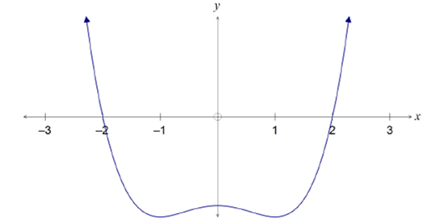

both roots accurate
three TPs at correct x-values
concave down at y-intercept
‘w’ shape with smooth continuous curve

END OF TEST

